**LG MS2595DIS NeoChef**

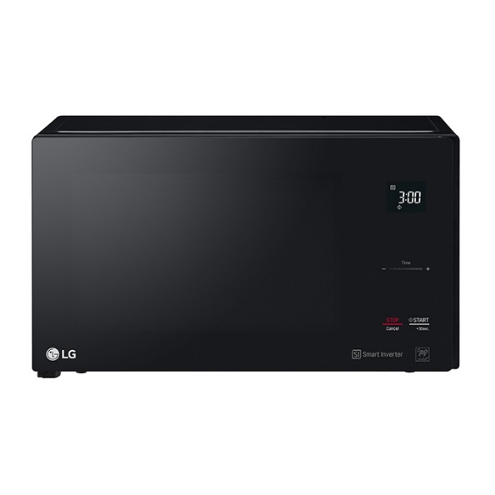

|  |  |
| --- | --- |
| **Capacity(litres):** | 25 |
| **Control System:** | Automatic |
| **Grill:** | Yes |
| **Color:** | Black |
| **Cavity:** | Painted |
| **Built-in Frame:** | No |
| **Net Width x Height x Depth:** | 472 x 286 x 361 |
| **Net Weight:** | 15 |
| **Nominal Power Microwave:** | 1000W |
| **Nominal Power grill:** | 1100W |
| **Microwave Power Levels:** | 4 |
| **Convection function:** | Yes |
| **Child Safely Lock:** | No |